QUESTION : 1
Install MySQL Community Server or SQLite on your system and verify the installation by connecting to the database using the command line or a GUI tool like MySQL Workbench or DB Browser for SQLite :

C:\xampp\mysql\bin\mysql.exe -u root
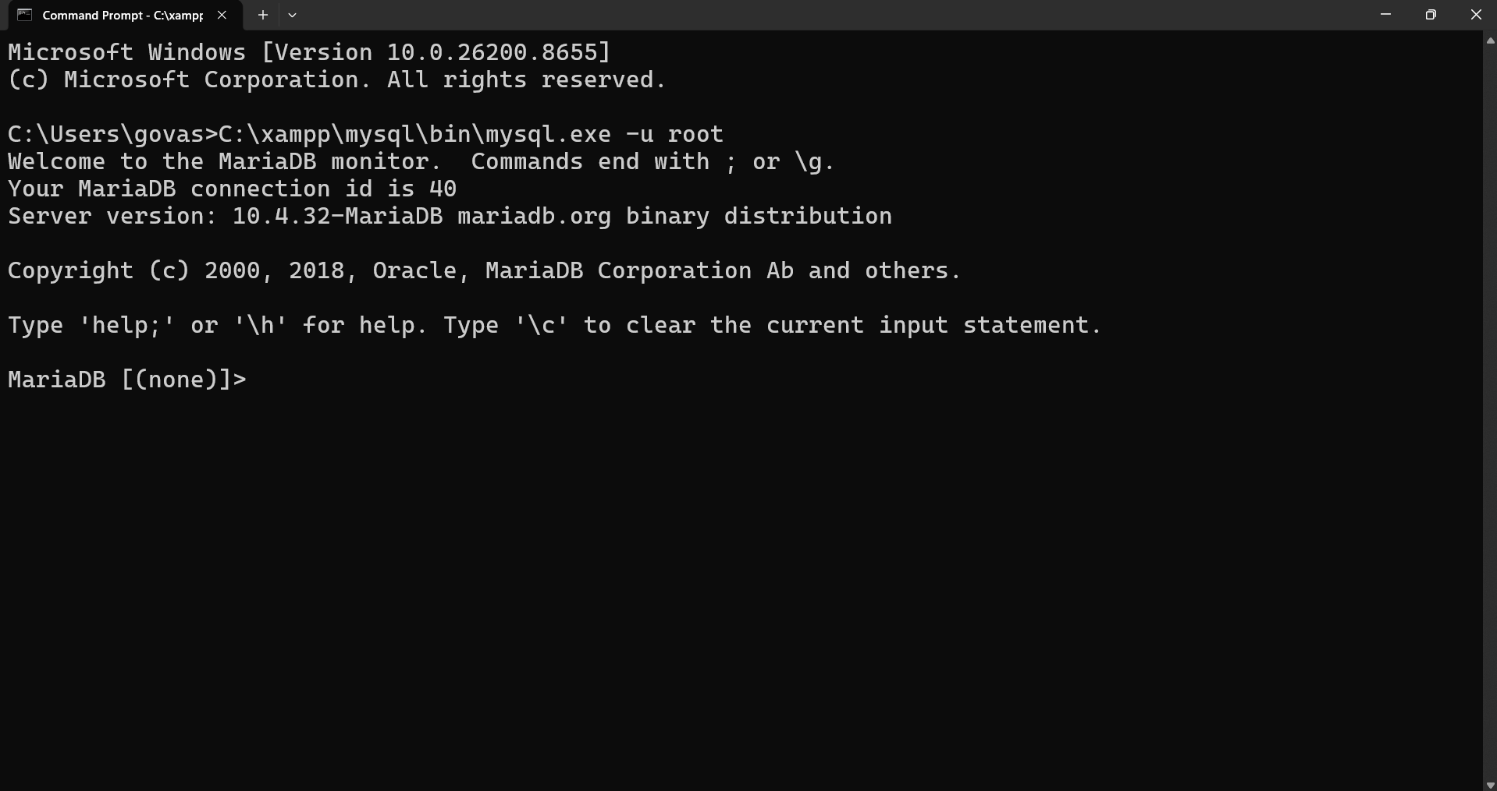

QUESTION : 2
Create a new database named 'foodie_app' to simulate a Zomato-style backend :

CREATE DATABASE foodie_app ;
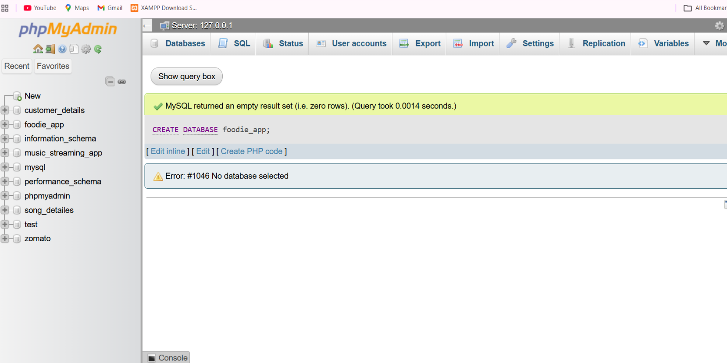
- USE foodie_app;

QUESTION : 3
Write a CREATE TABLE statement to define a 'restaurants' table in the 'foodie_app' database with the following columns: id (integer, primary key), name (varchar/character, max 100), cuisine (varchar/character, max 50), rating (decimal, e.g., 4.5), and location (varchar/character, max 100) :

CREATE TABLE restaurants ( id INT,
name VARCHAR(100),
cuisine VARCHAR(50),
rating DECIMAL(2,1),
location VARCHAR(100),
PRIMARY KEY (id)
);

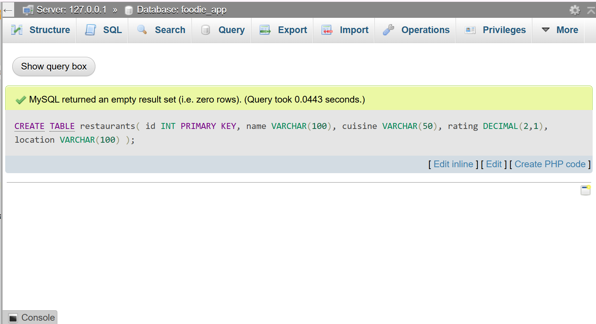

QUESTION : 4
Design and create a 'users' table for a Flipkart-style app with columns: user_id (primary key), username, email, phone_number, and created_at (date/time). Pick appropriate data types for each column.<br><br><em><strong>Hint:</strong> Think about which columns should be unique and which data types best fit email and phone numbers.</em>
- CREATE TABLE users(
user_id INT,
username VARCHAR(100) NOT NULL,
email VARCHAR(100) UNIQUE,
phone_number VARCHAR(12) UNIQUE,
created_at DATETIME,
PRIMARY KEY(user_id)
);
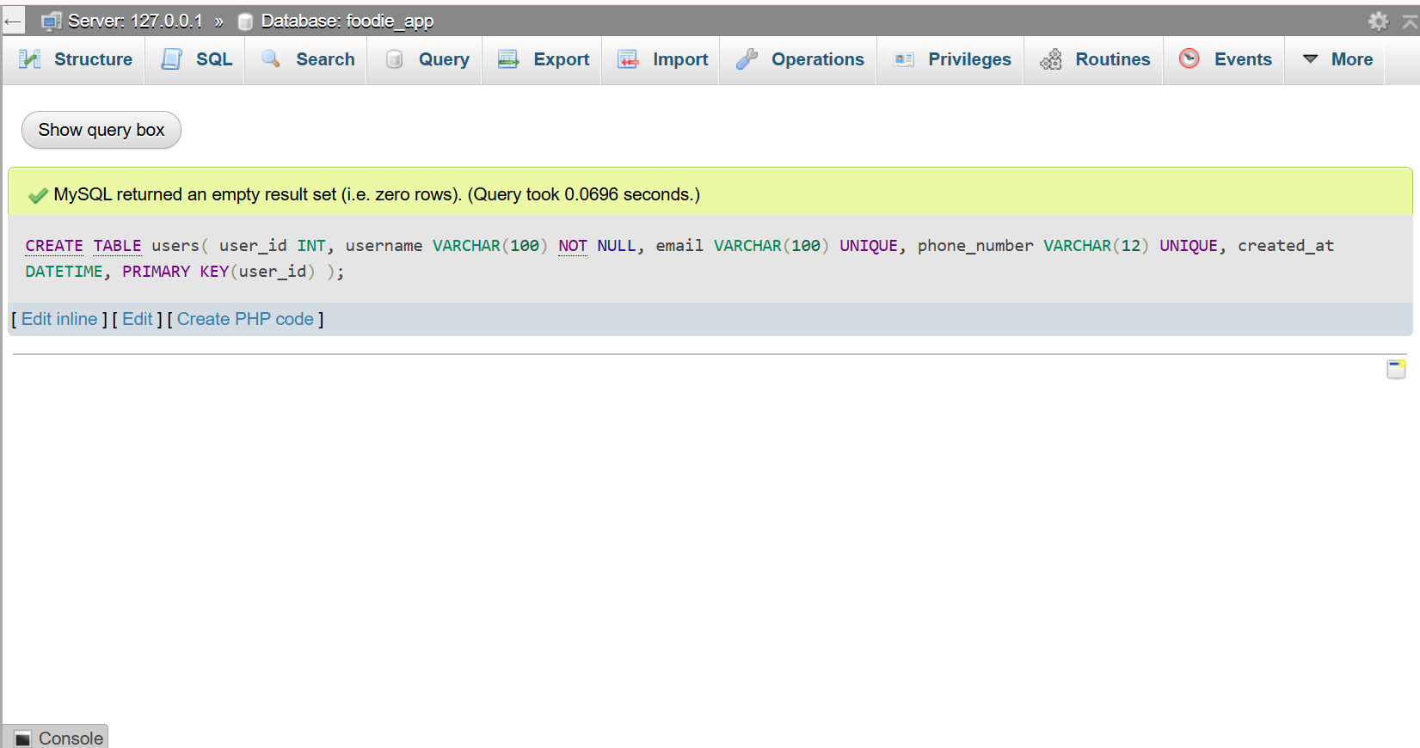

QUESTION : 5
Intentionally make a mistake in your CREATE TABLE statement (such as missing a comma or using an unsupported data type), run it, and then fix the error based on the message you receive.<br><br><em><strong>Hint:</strong> Take a screenshot of the error and the corrected SQL statement for your records.</em>

WRONG QUERY : 1
CREATE TABLE Student (
id INT PRIMARY KEY,
name VARCHAR(50)
age INT
);
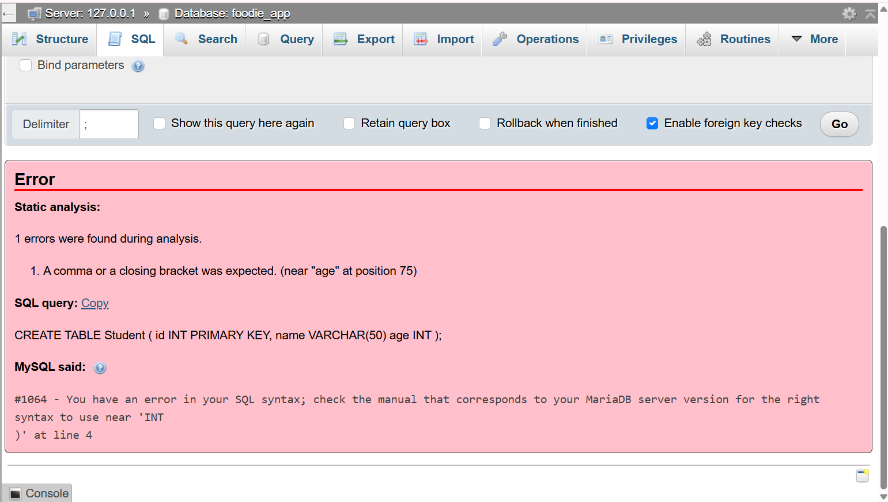

CORRECT QUERY 1 :
CREATE TABLE Student ( id INT, name VARCHAR(50) , age INT, PRIMARY KEY (id) );

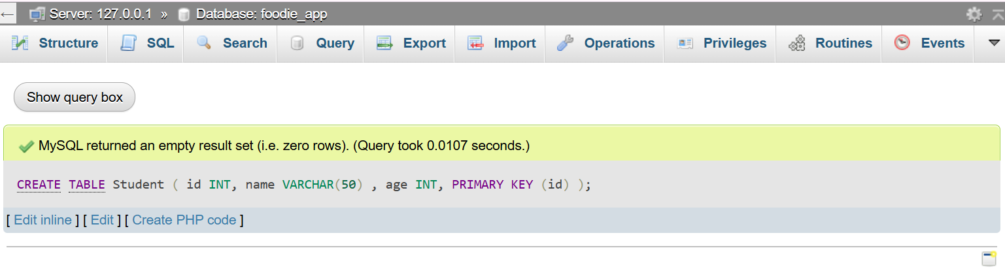
WRONG QUERY 2 :
CREATE TABLE Employee ( id INT, name VARCHARR(100));
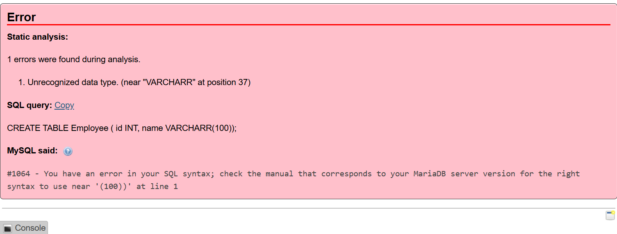CORRECT QUERY 2 :
CREATE TABLE Employee ( id INT, name VARCHAR(100));
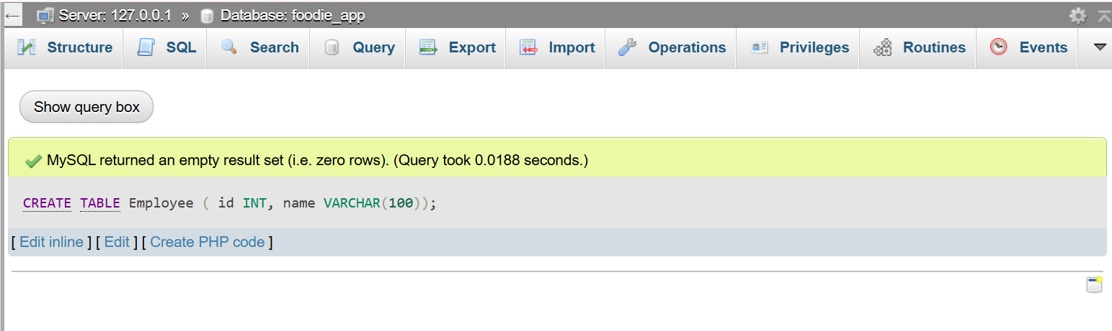
TASKS TABLS :
